**WAREHOUSE OPTIMIZATION: IMPROVING OPERATIONAL EFFICIENCY AT BOSCH LTD**

**BY**

**S RAJESH**

REG. NO: 950021631022

**A PROJECT REPORT**

Submitted to the

**FACULTY OF MANAGEMENT STUDIES**

*In partial fulfillment for the award of the degree*

*of*

**MASTER OF BUSINESS ADMINISTRATION**



**ANNA UNIVERSITY**

**CHENNAI 600 025**

**JUNE, 2023**



**ANNA UNIVERSITY REGIONAL CAMPUS – TIRUNELVELI**

TIRUNELVELI – 627007

**DEPARTMENT OF MANAGEMENT STUDIES**

**BONAFIDE CERTIFICATE**

Certified that the Project report titled **WAREHOUSE OPTIMIZATION: IMPROVING OPERATIONAL EFFICIENCY AT BOSCH LTD.,** is the bonafide work of **Mr. S RAJESH** who carried out work under my supervision. Certified further that to the best of my knowledge the work reported herein does not from part of any other report or dissertation on the basis of which a degree or award was conferred on an earlier occasion on this or any other candidate.

Signature of the Student Signature of Guide

**S RAJESH**  **Dr. S Silas Sargunam,**   
 **Assistant Professor**

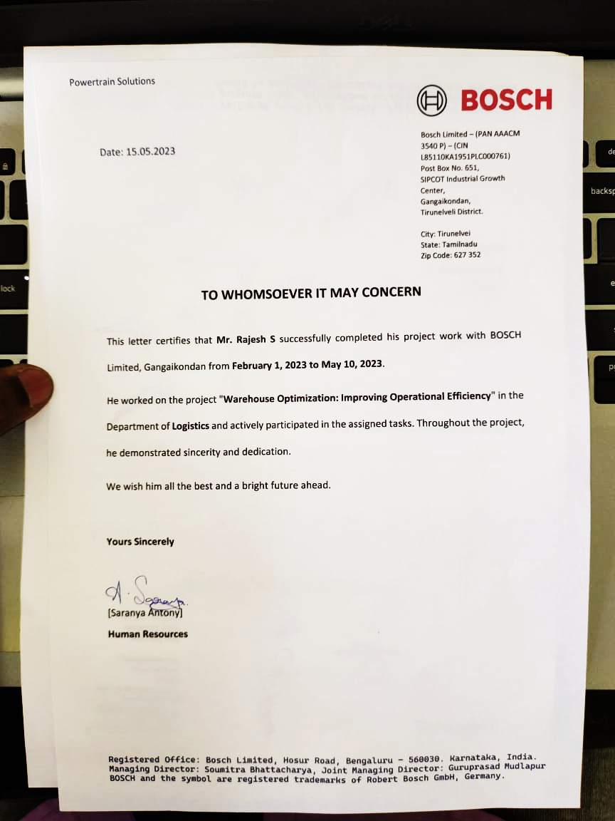

**S RAJESH**

**REG NO. 950021631022**

**DEPARTMENT OF MANAGEMENT STUDIES**

**ANNA UNIVERSITY REGIONAL CAMPUS, TIRUNELVELI REGION,**

**TIRUNELVELI-627007.**

**DECLARATION**

I **S RAJESH (950021631022)** hereby declare that the Project Report titled “**WAREHOUSE OPTIMIZATION: IMPROVING OPERATIONAL EFFICIENCY AT BOSCH LTD”** submitted by me in partial fulfillment for the award of the degree **MASTER OF BUSINESS ADMINISTRATION** of Anna University is my own work. The report has not been submitted for the award of any degree of the University or any other University before.

**Place: Tirunelveli S RAJESH**

**Date: (950021631022)**

**ABSTRACT**

This study examines warehouse management practices at Bosch Ltd Gangaikondan plant with the goal of improving efficiency and order fulfillment. By analyzing data related to inventory management, warehouse performance, order volume, transportation, and order complexity, the study identifies key findings and challenges. The findings include issues such as aged stocks, difficulties in analyzing warehouse performance, communication gaps between planning and warehouse operations, underutilized space, and the impact of various factors on order fulfillment rate. Based on these findings, practical suggestions are provided to address the identified challenges and enhance warehouse management. Implementing these recommendations can lead to improved operations and customer satisfaction. The study concludes by emphasizing the importance of adopting the suggested improvements to optimize warehouse practices and meet customer needs effectively. The research findings and recommendations serve as a valuable guide for Bosch Ltd Gangaikondan plant to enhance their warehouse management strategies and deliver better customer experiences.



**ANNA UNIVERSITY REGIONAL CAMPUS – TIRUNELVELI**

TIRUNELVELI – 627007

**DEPARTMENT OF MANAGEMENT STUDIES**

**Certificate of Viva-Voce-Examination**

This is to certify that **Mr. S RAJESH** (Register No.950021631022) has been subjected to Viva-voce Examination on …………………………....at the Department of Management Studies, Anna University Regional Campus, Tirunelveli-627 007.

Forwarded

Internal Examiner External Examiner

**ACKNOWLEDGEMENT**

I express my gratitude to our **DEAN, Dr. N. Shenbaga Vinaya Moorthi, M.E, Ph.D.,** Anna University Tirunelveli, who provided all facilities for carrying out this project.

I immensely thank to our Head of the Department of Management Studies **Dr.S.Silas Sargunam, M.E.,MBA.,PhD.,** Anna University Tirunelveli, for his valuable suggestions and guidance for the completion of project work and for guiding me throughout the work.

I am greatly indebted to **Dr.S.Silas Sargunam, M.E.,MBA.,PhD.,** Assistant Professor, Department of Management Studies, Regional Campus, Anna University, Tirunelveli Region, who have given a valuable suggestion for completing the project and preparing this report.

I express my sincere gratitude to all other faculty members of the Department of Management Studies for their expertise and help in my project.

I am thankful to all staff members and respondents of **BOSCH LTD, THIRUNELVELI** for their friendly co-operation to complete the project.

I acknowledge with sincere gratitude to my family members, friends for their inspiration and encouragement throughout this project.

**S RAJESH**

|  |  |  |  |
| --- | --- | --- | --- |
| **TABLE OF CONTENTS** | | | |
| **CHAPTER NO** | | **CONTENT** | **PAGE NO** |
|  |  | **ABSTRACT** | **V** |
|  |  | **ACKNOWLEDGEMENT** | **VII** |
|  |  | **TABLE OF CONTENT** | **VIII** |
|  |  | **LIST OF TABLES** | **X** |
|  |  | **LIST OF FIGURES** | **XI** |
| **1** |  | **INTRODUCTION AND RESEARCH PLAN** | **1** |
|  | 1.1 | INTRODUCTION OF THE STUDY | 1 |
|  | 1.2 | OVERVIEW OF INDUSTRY AND COMPANY | 2 |
|  | 1.3 | NEED FOR THE STUDY | 14 |
|  | 1.4 | STATEMENT OF THE PROBLEM | 14 |
|  | 1.5 | RESEARCH QUESTIONS | 15 |
|  | 1.6 | OBJECTIVES OF THE STUDY | 15 |
|  | 1.7 | SCOPE OF THE STUDY | 15 |
|  | 1.8 | LIMITATIONS OF THE STUDY | 16 |
| **2** |  | **LITERATURE SURVEY** | **17** |
|  | 2.1 | INTRODUCTION | 17 |
|  | 2.2 | REVIEW OF LITERATURE | 18 |
|  | 2.3 | RESEARCH GAP | 20 |
| **3** |  | **RESEARCH METHODOLOGY** | **22** |
|  | 3.1 | INTRODUCTION | 22 |
|  | 3.2 | RESEARCH DESIGN | 22 |
|  | 3.3 | JUSTIFICATION OF SELECTING THE STUDY AREA | 22 |
|  | 3.4 | DATA COLLECTION | 23 |
|  | 3.5 | RESEARCH TOOLS AND TECHNIQUES USED | 24 |
| **4** |  | **DATA ANALYSIS AND INTERPRETATION** | **25** |
|  | 4.1 | INTRODUCTION | 25 |
|  | 4.2 | DESCRIPTIVE ANALYSIS | 25 |
|  | 4.3 | INFERENTIAL ANALYSIS | 30 |
| **5** |  | **FINDINGS, SUGGESTIONS AND CONCLUSIONS** | **33** |
|  | 5.1 | INTRODUCTION | 33 |
|  | 5.2 | FINDINGS | 33 |
|  | 5.3 | SUGGESTIONS | 34 |
|  | 5.4 | SCOPE FOR FUTURE RESEARCH | 36 |
|  | 5.5 | CONCLUSIONS | 37 |
|  |  | **BIBLIOGRAPHY** | **39** |

|  |  |  |
| --- | --- | --- |
| **LIST OF TABLES** | | |
| **TABLE NO** | **PARTICULARS** | **PAGE NO** |
| 4.1 | Difference variables used in Regression Analysis with values in different months | 30 |
| 4.2 | Variables with Values used in Regression Analysis | 31 |

|  |  |  |
| --- | --- | --- |
| **LIST OF FIGURES** | | |
| **FIGURE  NO** | **PARTICULARS** | **PAGE NO** |
| 4.1 | Warehouse Utilization Power BI Dashboard | 26 |
| 4.2 | FG/RM Depth View-Power BI Dashboard | 27 |
| 4.3 | Warehouse High Rack Power BI Dashboard | 28 |
| 4.4 | Warehouse High Rack Power BI Dashboard | 29 |